#Marcus Nash

#CSCI-486: Theory of Computing

#Dr. Fatima Boukari

#04/30/2019

Directions:

“For this project assignment, you are to write up your own program and turn in a brief technical report, source code (each student needs to turn in his own source code). The technical report will include a description of your work, your approach, your methods, task of each of your functions, your data structures. Your project takes “TestStrings.txt” as input and automatically generates the results in a text file that you name “Results.txt”.”

The readfile function takes in the name of the file “TestStrings.txt”. It open up the file to get list of all the given lines. Next we have a random function that to chooses whether J is equal to I or K.

If “J” is equal to “I” we will loop through the list of strings and for every string in the list we will put it into the (accept_or_reject(string)) function to see if it passes the PDA test. The PDA test implemented as a stack and used to keep track of the current states going forward. The same amount of a’s pushed in should be the same number of b’s popped. Then is that is success full we must check to see that the c’s left are only c’s. Once we get to the end as defined as “\n” we will the return approved. Once the function is returned it gives a string of approved or rejected and is then concatenated with the string that was tested and written into the Results.txt folder.

If “J” is equal to “K” then we do the same process as above. The main difference being that fact we do it in reverse order. So the string “aabbcc” would first be turned into “ccbbaa” and then the c’s pushed should be the same b’s popped and then count, then check to see that the a are consecutive up until we find “\n”. Easy trick to using the same code twice and being able to retrieve correct results.

This was the example PDA graph that was followed. Started out it the top portion which shows If the string is a i b j c k with i = j, then the PDA takes the branch from q1 to q2.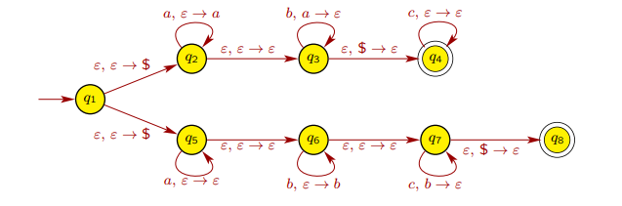

The string is a i b j c k with j = k, then the PDA takes the branch from q1 to q5. But it seemed more appropriate to reuse the code from above and switch the letters around as it is technically asking the same question in reverse.

